Topic A Projects – Due Tuesday 9/9

- Type in the following program. The idea is not to understand how the program works (not just yet, anyway) but to be able to type the program into the IDE, then compile, link, and run it.
You will need to run the program 5 times, one for each of the input values shown in the table. Hand in the program in a file called TopicA_1.cpp.
Be sure to include your name and the file name as a comment at the beginning of the program
Include the required table at the end of your program as a comment (or comments).

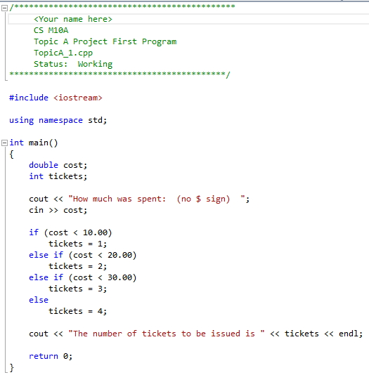
This ends in a lower case L not the number 1
Substitute with your name here

If the customer spends this much | This many tickets are given
$5.35
$10.00
$18.00
$25.76
$30.01

- Do Programming Challenge 8 in Chapter 2 (2.8 where the first part is the chapter number) on page 80 of the text. The file should be called TopicA_2.cpp. Variables are to be used, not their values, in any calculations or in any output statements. Make the sales tax rate a named constant in your program.
Run the supplied executable to see what the output should look like. Remember to include your name, the file name, and the status as comments at the beginning of the program. (Note: We will learn how to get the correct number of decimal places in the next Topic. Do not worry about that now.)
If there is any question on how to do this project and what to turn in, be sure to refer to the Assignment Grading Criteria document. (The last line in my program, where you Press Enter to end, is not something you need put into your program. When you create your own program, the last line in the console window, "Press any key to continue", is from Visual Studio, not from your program. You cannot prevent Visual Studio from displaying that line.)
Note: When you attempt these programs in Visual Studio if the console window immediately closes without allowing you to see your program output, then make sure you used
"Start Without Debugging" from the "Debug" menu as per the Using Microsoft Visual Studio documents. You can also use the keyboard shortcut, Ctrl+F5. (This means to first press the Ctrl key. Then, while holding that key, also press the F5 key.) (Do not use F5 by itself.)
If this does not solve the problem make sure that you created the correct project as per the Using Visual Studio documents.

